Call for Papers and Posters
33rd Annual Kentucky Heritage Council
Archaeology Conference
Celebrating the 50th Anniversary of the
National Historic Preservation Act in Kentucky
March 11-13, 2016
Pine Mountain State Resort Park

The 33rd Annual Kentucky Heritage Council Archaeology Conference will be hosted in partnership with the Kentucky Organization of Professional Archaeologists and Kentucky Archaeological Survey at Pine Mountain State Resort Park
near Pineville, Kentucky. In honor of the 50th anniversary
of the passage of the National Historic Preservation Act (NHPA), much of this year’s conference will be devoted
to celebrating the impacts of this significant event in Kentucky Archaeology. For those who wish to present, please complete
the form below and submit no later than January 31, 2016
via email to Kary Stackelbeck (kary.stackelbeck@ky.gov).

Accommodations:
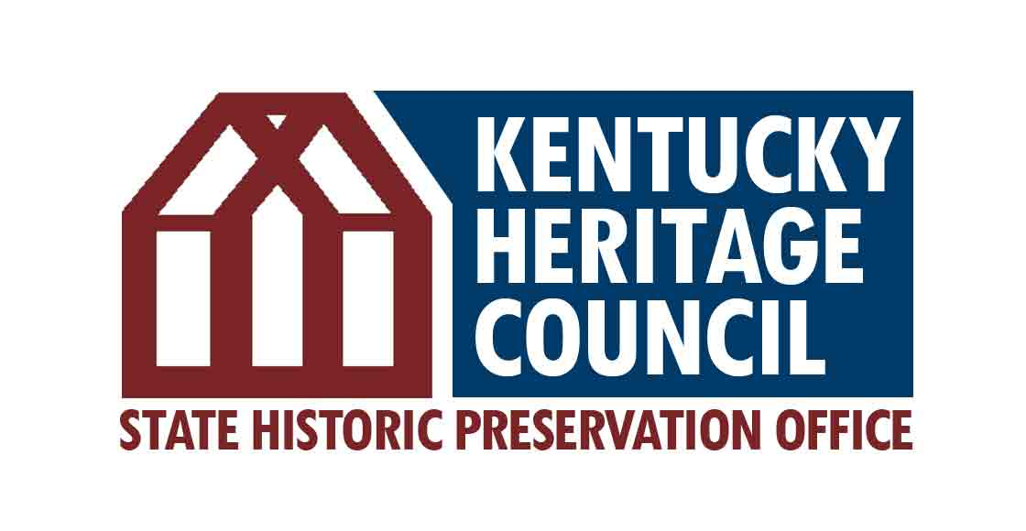
A block of lodge rooms at the conference rate of $84.95+tax has been reserved for Friday, March 11th and Saturday, March 12th. Cottages and cabins are available at discounted rates of $118.95 and $93.45, respectively. To receive this group rate, please book your rooms by Tuesday, February 9, 2016 by calling (606) 337-3066 or (800) 325-0057 and indicate that you are with the KHC Archaeology conference.
33rd Annual KHC Archaeology Conference Submission Form
Presentation Format (please select one):
☐ Oral/Powerpoint (20 minutes)
☐ Poster (to be displayed during Saturday evening reception)

Presentation Topic (please select one):
☐ The Democratization of Kentucky Archaeology: From the awe-inspiring to the quotidian, highlighting sites that would not likely have been investigated or documented but for the NHPA and what they taught us about Kentucky’s rich cultural heritage.
☐ The Team Approach to Historic Preservation: Successful examples of studying the past through NHPA-
related projects that have benefitted from interdisciplinary or interagency approaches, or the engaged involvement of multiple actors in tandem with the professional archaeologists (e.g., Indian Tribes, Consulting Parties, members of the public, school groups).
☐ Stewards of Kentucky’s Heritage: Significant sites that are being actively protected for future generations because of the NHPA, including those on public lands and those that are under easement on private property.
☐ NHPA Archaeology—Then and Now: Retrospectives on changes and developments in NHPA-invoked compliance, standards, documentation, and research.
☐ Thinking Outside the Box, but Inside the NHPA: Examples of successful creative compliance measures OR How archaeology can contribute to underutilized components of the NHPA, such as Traditional Cultural Properties, Cultural Landscapes, Designed Landscapes that Include Scenic Vistas, or Rural Historic Landscapes.
☐ Making Kentucky Archaeology Public: An off-shoot of the Nation-wide campaign, Making Archaeology Public, this is a collection of papers and/or posters that highlight the most important insights into life in the past that we have gained from CRM archaeology in Kentucky and the wide variety of efforts to make that research accessible to the Public. Papers under this theme could relate to 106 mitigation, projects funded through Survey and Planning Grants from KHC, or other successful Public-Private partnerships that were facilitated through the NHPA. This session is expected to lead into a focused planning meeting for Kentucky Archaeology Month events.
☐ Other NHPA-related subject:
☐ General Session (non-NHPA-related)
Presentation Title:
Presenter Name(s) and Affiliation(s):
Presentation Abstract (Maximum of 100 words per individual submission):

