Outreach Notice
for (1) Permanent Full Time District Archeologist, GS0193/09
on the Daniel Boone National Forest, Redbird Ranger District

Respond by June 18, 2018

The Redbird Ranger District of the Daniel Boone National Forest is looking for a highly motivated individual to serve as District Archeologist. The incumbent will be responsible for inventory, evaluation, and advice on heritage and cultural resource management, including determination of effects of projects on cultural resources and recommended mitigation.

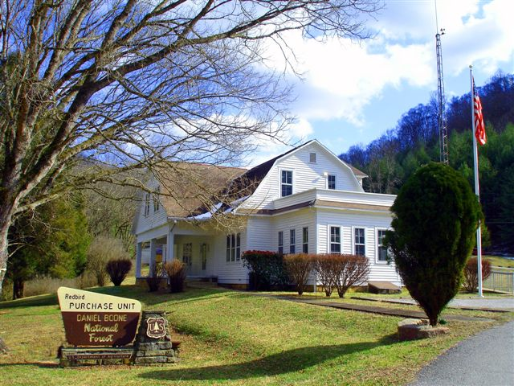

Major duties for the position include, but are not limited to:

Provides advice on identification and management of Heritage and Cultural Resources Program, including development of immediate objectives, integration with resource activities, and establishment or priorities.

Assists in ensuring integration with heritage and cultural resource activities and establishment of priorities. The Heritage and Cultural Resource Program covers one or more resource areas, such as the protection of historic and pre-historic properties and artifacts.

Coordinates the budget and project plan of work for the unit’s archeological and cultural activities within the NF unit.
Designs inventory strategies as part of the land use planning process based on Forest-wide priorities and needs.
Organizes, supervises, or directly performs inventory of areas. Work includes preparation of maps, inventories, reports, and records related to the discovery, protection, inventory, salvage, and interpretation of heritage and cultural resource areas.
Reviewing reports as part of project planning to evaluate the quality of the inventory, the completeness of the report, and the significance of heritage or cultural sites found. Prepares determinations of effect for such projects identified during project inventories. Recommends mitigation procedures.
Determines eligibility of historical properties for the National Register of Historic Places.
Provides heritage and cultural resource management orientation to Forest Service personnel on statutes, regulations and purpose of work to be performed.
Interprets heritage and cultural resources to the public and professional contacts through presentations at visitor facilities, professional journals, etc.
Develops contract specifications for heritage and cultural resource work and as delegated, acts as COR or inspector on such contracts.
Assists in developing and carrying out projects related to stewardship enhancement and public interpretation of heritage and cultural resources, such as partnership agreements and site steward programs.
Interprets heritage and cultural resources to public and professional contacts through presentations at professional conferences, visitor facilities, professional journals, etc.
Ensures program data for documentation submission including contracts, National Register of Historic Places (NRHP) eligibility criteria, legal documents to fulfill programmatic requirements, and internal reports.

DISTRICT INFORMATION

REDBIRD RANGER DISTRICT (Big Creek, KY)
The Redbird Ranger District is one of the newest units in the Southern Region. Purchased in 1965, the district is blessed with a richly diverse and scenic hardwood forest and abundant wildlife reminiscent of that encountered by pioneering frontiersmen over 200 years ago. In fact, the District is at the heart of the largest free ranging elk herd east of Montana. The expanding elk population is expected to reach 11,000 animals this year.
The unit encompasses over 145,000 acres in the headwaters of the South and Middle Forks of the Kentucky River of southeastern Kentucky. The Redbird Wildlife Management Area is located in the center of the District and is approximately 24,000 acres of Federal land, making it the largest cooperatively-managed wildlife management area in the state. Forest vegetation is predominately mixed hardwoods. Steep slopes separated by narrow ridges and valleys characterize the terrain known as the rugged foothill section of the Appalachian Mountains.
Recreational opportunities on the district include hunting, fishing, hiking, picnic areas, and scenic byways. Of interest to many off-road enthusiasts is our Redbird Crest Trail, a 100-mile long multiple use trail open to OHV, motorcycle, mountain bikes, horses and foot travel. Our trail system currently connects with the Leslie County Daniel Boone Trail system.
The District recently initiated a collaborative watershed improvement effort for the Red Bird River that brought together a variety of local, state and federal governmental agencies and residents of local communities to write a watershed plan - a plan to provide a blueprint for better water quality in the Red Bird River. The plan identified a variety of water quality issues, opportunities for dealing with those issues, and strategies for the protection and restoration of healthy conditions in the Red Bird River watershed that will guide the District’s program of work in the coming years.

COMMUNITY INFORMATION
BIG CREEK

The Redbird Ranger Station is located on the banks of the Redbird River at the historic town site of Peabody, which is near the town of Big Creek, Kentucky. Our Ranger Station, a historic building built in 1924 by the Fordson Coal Company, a subsidiary of the Ford Motor Company, is in a rural setting approximately three miles off the Hal Rogers/Daniel Boone Parkway. The Ranger Station had a complete renovation in 2012, and has been nominated to the National Register of Historic Places. The office is located in Clay County, 17 miles east of Manchester, the county seat.
Manchester is a full service community of approximately 2,500 people and has banks, doctors, dentists, clinics, a hospital, several churches, a variety of fast food restaurants, a Wal-Mart and many other small shops and businesses. There is a golf course at Manchester as well as a swimming pool, tennis courts, volleyball courts, and baseball and softball fields.
Other full service communities in the local commuting area include London (37 miles west, on the Hal Rogers/Daniel Boone Parkway), and Hazard (29 miles east, on the Hal Rogers/Daniel Boone Parkway). Lexington and Knoxville are 110 miles and 130 miles respectively. Other major cities in the east accessible via Interstate are Atlanta (5 hours), Louisville (3 ½ hours), and Cincinnati (3 ½ hours).
The Clay County school system has one high school (grades 9-12) that was opened in 1991; one junior high (grades 7-8); and 9 elementary schools (grades K-6).
The Big Creek Elementary School is located three miles from the District Office. The Redbird Mission at Queendale (United Methodist Church affiliation) operates a K-12 school as well as a clinic staffed with a doctor, dentist, and an ambulance service. The Redbird Mission is about 14 miles up the Redbird River from the District Office.
Housing is limited in the Big Creek area. However, housing may be available on the compound. Houses are moderately priced ($75,000 – $250,000) in the communities of Manchester and London. Cost of living is moderate.

DANIEL BOONE NATIONAL FOREST

The Daniel Boone National Forest is located along the Cumberland Plateau in the Appalachian foothills of eastern Kentucky. The forest encompasses over 706,000 acres of mostly rugged terrain. The land is characterized by steep forested ridges dissected by narrow ravines and over 3,400 miles of sandstone cliffs.

These lands are federally managed to provide the nation with a sustained yield of natural resources, including wood, water, forage and wildlife. Recreation opportunities on the national forest are an added bonus. The conservation management of natural resources and recreation provides significant economic, environmental and social benefits in the public interest.

Millions of visitors come to enjoy the scenic beauty and abundant wildlife that the forest has to offer. Cave Run lake and Laurel River Lake are popular attractions on the forest. Other special areas include the Red River Gorge Geological Area, Natural Arch Scenic Area, Clifty Wilderness, Beaver Creek Wilderness, and five wildlife management areas.

Over 600 miles of trails provide a quiet escape to more remote places within the forest. Hikers, horseback riders and other trail users get back to nature along the 269-mile Sheltowee Trace National Recreation Trail that extends the entire length of the Daniel Boone. Hundreds of miles of winding rivers and streams provide the finishing touch in outdoor beauty.

Candidates may learn more about the Forest by visiting our web site. http://www.fs.fed.us/r8/boone

If you are interested in this position, please fill out the attached outreach response form stating your interest, current qualifications and a short resume and return to

If you are interested in this opportunity, please send an email response stating your interest by COB June 18, 2018 to Bobby Claybrook @ rclaybrook@fs.fed.us.

If you have questions regarding this opportunity, please call Bobby Claybrook or Trish Boles at 606-598-2192.

RESPONSE OUTREACH FORM
District Archaeologist (Permanent Full Time)
GS-0193-09
Redbird Ranger District
Daniel Boone National Forest
Big Creek, KY
Please Reply By June 18th , 2018

Name: ____________________________ E-Mail Address: _________________________

Telephone Number: _________________________

Are you currently a permanent Federal Employee? YES ______ NO _______

If YES, current Agency/Region/Forest/District: _________________________________________________

Current Title/Series/Grade:__________________________________

If not a current permanent (career or career conditional) employee, are you eligible to be hired under any of the following special authorities?

____ Person with Disabilities
____ Veterans Readjustment
____ Disabled Veteran w/30% Compensable Disability
____ Veterans Employment Opportunities Act of 1998
____ Former Peace Corps Volunteer
____ Student Career Experience Program
____ Other _____________________

Please indicate your highest level of education related to archeology.

___ Bachelors
___ Masters
___ PhD
___ None of the above

Please indicate where you have 1 year or more of archeological field experience.

____ United States
____ Eastern United States
____ Ohio River Valley (Kentucky, Tennessee and adjacent portions of surrounding states)
____ Kentucky
____ Historic Sites
____ Pre Contact Sites
____ Phase II and/or Phase III work
Please send this completed form to:
Bobby Claybrook, District Ranger
Email: rclaybrook@fs.fed.us,
FAX: (606) 598-3648,
US mail: Bobby Claybrook, District Ranger
Redbird Ranger Station
91 Peabody Road
Big Creek, KY 40914

Thank you for your interest in our Forest.
USDA Daniel Boone National Forest is an equal opportunity employer.

